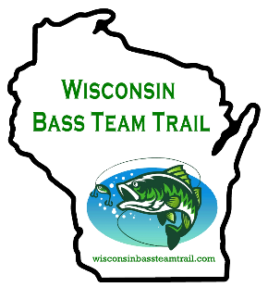
Boater: _______________________
Non-Boater: ___________________
2026 Entry Form

WBTT Series presented by TBD
$170 ____ Lake Mohawksin, May 30
$170 ____ Lake Nokomis, June 27
$170 ____ Willow Flowage, July 11
$170 ____ Manitowish Waters, Aug 15
All entries include big bass pot ($20)
Amount PD: ________________
Amount PD: ________________
Amount PD: ________________
Amount PD: ________________
Membership ($35 per person) PD: _______

Up/Down
Includes $20 for big bass each day
$120 ____ Point Flowage, Aug 8
$120 ____ Biron Flowage, Aug 9
Total Paid: __________________

$170 _____ Entry Fee Day One Includes big bass ($20) Total Paid:_____________

Rod Gaskill Memorial – August 22, 2026
TOTAL PAID BY TEAM: ____________________________________

Mail entry, signed waiver at the end of the rules, and
proof of $300,000 property damage/watercraft liability insurance for all boats to be used
during the Wisconsin Bass Team Trail event to:

Wisconsin Bass Team Trail
107 E. 11th St
Marshfield, WI 54449

Make checks payable to Wisconsin Bass Team Trail

Primary Angler (Please print)
Name_____________________________________________
Address___________________________________________
City_________________________ State______ Zip________
Telephone_______________________________________
Email __________________________________________

Partner Angler
Name_____________________________________________
Address___________________________________________
City________________________ State______ Zip________
Telephone_______________________________________
Email ___________________________________________

All team members are responsible for reading and knowing the rules of these tournaments. You agree to this by sending in the entry form.
Find all of the rules and the waiver form at WisconsinBassTeamTrail.com

See website for entry opening and deadlines. All WBTT tourneys must be paid one week before. Opens may be paid at the ramp, but teams will be placed at the end of the field as they sign up.

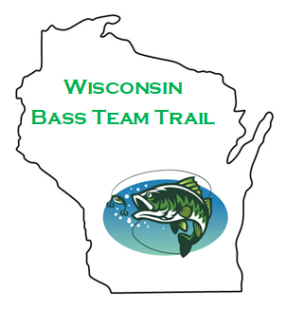

TBD

Low entry– 90 % payout events

5 fish limit

2-Person Team Events

Great Community Support

Team of the Year Award

4 events

Great 2-Day Championship
100 % payback on Winnebago Chain 2026
ALSO 2 great opens!

